Patterns, mechanisms and implications of interactions among ectomycorrhizal fungi, twig endophytes, plant traits and
the genetics of Populus angustifolia

Jamie Lamit’s Prospectus

Introduction

Plants are typically thought of as discrete entities. Often overlooked are the numerous microorganisms, including fungi, that are associated with belowground and aboveground plant tissues. These organisms are a little understood wealth of biodiversity and can have strong impacts on plant physiology, ecology and evolution (Trappe and Luoma 1992, Redecker et al. 2000, Hawksworth 2001, Brundrett 2002, Herre et al. 2007). For example, arbuscualar mycorrhizal fungi, which form symbioses with the roots of the majority of land plants, are known to impact plant communities and may have facilitated the movement of plants onto land ~450 million years ago (Johnson et al. 1997, Van der Heijden et al. 1998, Redecker et al. 2000). The following research prospectus is largely focused on understanding patterns, mechanisms and implications of intimate plant–fungal associations.
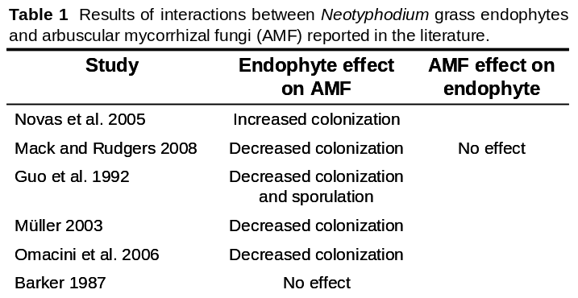
My research will focus on two groups of plant associated fungi: horizontally transmitted endophytes that live symptomlessly in localized infections within the aboveground tissues of all woody plants surveyed (Wilson 1995a, Saikkonen et al. 1998), and ectomycorrhizal fungi who live on and within the fine root tips of many dominant woody plants (Smith and Read 2008). Ectomycorrhizal fungi are often mutualists who trade nutrients and water with plants in exchange for photosynthate (Smith and Read 2008), although these relationships are not always beneficial to both partners (Johnson et al. 1997). Much less is understood about the relationship between endophytic fungi and their hosts (Saikkonen et al. 1998, Arnold 2007). Endophytes obtain both nutrients and energy from the plants they live within, and have been shown to impart beneficial and negative effects (Pinto et al. 2000, Arnold et al. 2003, Arnold and Engelbrecht 2007). There are four key points I want to make about these fungi. 1.) Both groups of fungi come from multiple fungal lineages and can form diverse communities associated with individual plants (Ishida et al. 2007, Arnold 2007). 2.) There is evidence of specificity or preference at the level of plant family, genus, species and genotype for some members of each of these fungal groups (Molina et al. 1992, Elamo et al. 1999, Ishida et al. 2007, Higgins et al. 2007, Arnold 2007, Morris et al. 2008). 3.) Both can have important impacts on the functioning of plants (Herre et al. 2007, Baxter and Dighton 2001, Quoreshi and Khasa 2008). 4.) Due to their intimate interactions with hosts, these fungi can be sensitive to plant physiological and chemical traits, some of which are genetically based (Barker and Tagu 2000, Bailey et al. 2005). These points indicate that interactions of ectomycorrhizal and endophytic fungi with their host plants can have important ecological and evolutionary implications at multiple scales (Trappe and Luoma 1992, Herre et al. 2007, Smith and Read 2008). Furthermore, they suggest the possibility for indirect interactions between the two groups of fungi through their effects on their shared host plant. To my knowledge, this last point has not been investigated in woody plants, but evidence from grass systems indicates that fungi in spatially segregated host tissues can affect each other (Table 1.).
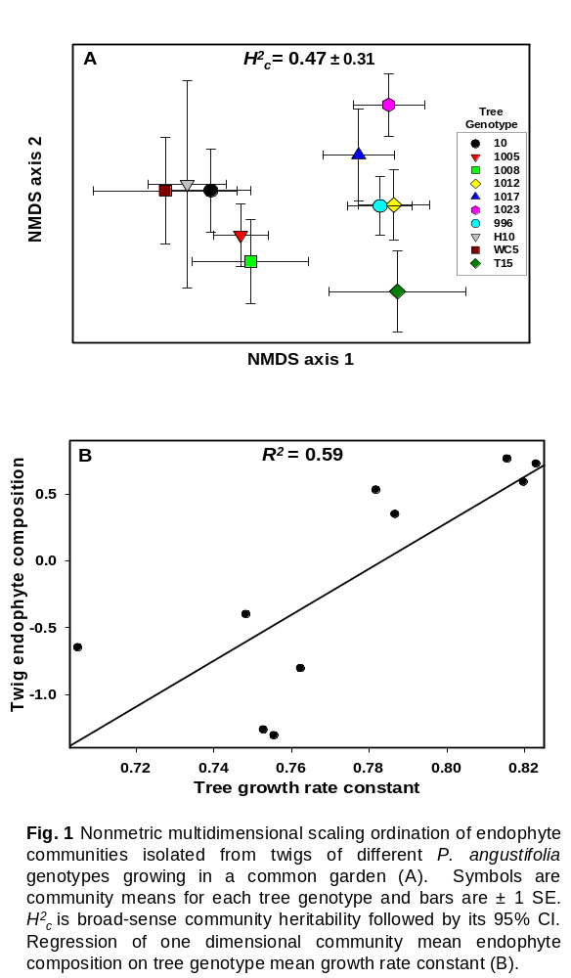
The field of community genetics seeks in part to understand the genetic components of community structure, and their ecological and evolutionary implications (Whitham et al. 2003, 2006, Johnson and Stinchcombe 2007, Whitham et al. 2008). In many systems, ranging from oak woodlands (Boecklen and Spellenberg 1990) to sea grass beds (Reusch et al. 2005), genetic differences among individuals have been shown to affect hundreds of diverse organisms sensitive to genetic variation in ecologically important quantitative traits, including plant secondary chemistry, phenology and vigor (Floate and Whitham 1993, Johnson and Agrawal 2005, Crutsinger et al. 2008, Wimp et al. 2008). These patterns are typical of systems dominated by foundation species, who create locally stable conditions and modulate resources and ecosystem processes (Dayton 1972, Ellison et al. 2005). Communities on plant genotypes may be heritable in the broad-sense (i.e., clonal replicates of a genotype support similar communities), indicating strong linkages to plant genes and the potential for evolutionary forces to act on the interactions (Shuster et al. 2006, Whitham et al. 2008). Although the field has progressed greatly in the last decade, the primary focus of most community genetics studies has been on plant-foliar arthropod interactions, and there is still a lack of understanding on how fungal communities are influenced by the genes of plants they associate with. From the few studies that have been conducted on fungi, we know that at various levels, both ectomycorrhizal and endophytic fungal communities are sensitive to genetic differences among different plant genotypes (Elamo et al. 1999, Bailey et al. 2005, Sthultz 2008). My own work has shown that communities of endophytic fungi associated with twigs of Populus angustifolia (narrowleaf cottonwood) demonstrate significant broad-sense heritability among replicated tree genotypes in a common garden environment, and that endophyte communities are linked to plant growth rate (Fig. 1). This pattern suggests that twig endophyte interactions with plant genotype may be important for fungi and their associated plants in both an ecological and evolutionary context.
There is a major push in ecology to identify plant traits indicative of physiological and ecological strategies, that are useful in making predictions about ecological patterns concerning topics ranging from community assembly to plant community response to climate change (Grime et al. 1997, Wright et al. 2004, McGill et al. 2006, Westoby and Wright 2006). One component of this research aims to find easy to measure traits (e.g., specific leaf area, the area of a single side of a leaf divided by the leaf’s dry mass) that are predictive of a wide variety of physiological traits more difficult to measure (Weiher et al. 1999). This has proved fruitful because many plant functional traits are linked to very basic physiological controls and tradeoffs, leading to correlations among traits (Reich et al. 2003, Shipley et al. 2006). Although this field discusses functional traits in an evolutionary context, dialogue is primarily focused on species differences (e.g., Reich et al. 2003). I believe that it is important to focus on genetically based variation within species if we want to understand patterns and mechanisms associated with the evolutionary ecology of these traits. Furthermore, there is great potential to integrate this functional trait approach with community genetics and fungal ecology. Ectomycorrhizal and endophytic fungi closely associate with plants, influence the expression of many quantitative traits that can be considered “functional traits”, and are affected by others (Herre et al. 2007, Quoreshi and Khasa 2008). Genetically variable functional traits may be useful in predicting components of fungal community structure. Interactions between plant functional traits and associated fungi may also be open to forces of natural selection if interactions vary among plant or fungal genotypes.
There are at least three major points to take away from this introduction, which I intend to address with my PhD research. 1.) Communities of ectomycorrhizal and endophytic fungi are sensitive to, and may affect, important plant functional traits. 2.) The field of community genetics needs to widen its focus to include patterns and mechanisms of fungal interactions with different plant genotypes. 3.) The functional trait approach should be integrated with fungal community ecology and community genetics, to better understand the expression of plant traits and predict components of fungal community structure. Please keep these points in mind as you read through the following chapters.

Chapter 1: Patterns and mechanisms of tree genotype influence on the structure of ectomycorrhizal communities.

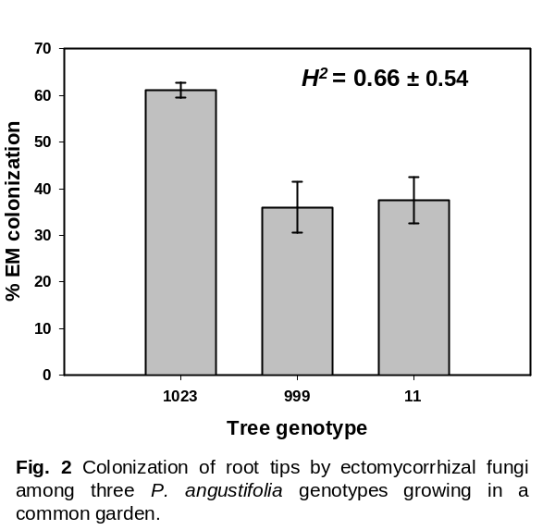
Introduction: This chapter will be a continuation of work I have already started that examines the influences of different P. angustifolia genotypes on ectomycorrhizal fungal communities. It will complement the study I completed focusing on twig endophyte communities from the same trees (Fig. 1). P. angustifolia is considered a foundation species, and a large body of work indicates that there are heritable differences among genotypes within this species for the composition and stability of foliar arthropod communities (Keith et al. in review), soil microbial community composition (Schweitzer et al. 2008), decomposition and nitrogen mineralization rates (Schweitzer et al. 2005, Schweitzer et al. 2009), aphid-bird interactions (Bailey et al. 2006), bark lichen community composition (Lamit et al. unpublished) and, as already mentioned, twig endophyte community composition (Fig. 1). In light of these effects on a variety of organisms and processes, it is likely that ectomycorrhizal fungal communities, which are intimately associated with tree roots, will vary among P. angustifolia genotypes. This notion is supported by pilot data (Fig. 2).
In addition to documenting patterns of ectomycorrhizal communities among tree genotypes, I would like to elucidate some potential mechanisms and effects of community patterns. Ectomycorrhizal communities may be influenced by the direct biochemical signaling which occurs between fungi and plants at the interface of the mycorrhizal symbiosis (Barker and Tagu 2000, Tagu et al. 2002, Martin et al. 2001), and indirectly through leaf and root litter effects on soil properties (Hättenschwiler and Vitousek 2001, Kraus et al. 2003, Read and Perez-Moreno 2003, Harington and Mitchell 2005). P. angustifolia shows important intraspecific variation in phytochemical traits, such as leaf condensed tannin concentrations (Bailey et al. 2006, Lamit et al. unpublished), which may be one cause of variation in soil nitrogen cycling under different tree genotypes (Schweitzer et al. 2009). Chemical alteration of soil nutrient cycling and mediation of the effects through mycorrhizal fungi has been proposed as an adaptive strategy for some woody plants, however there is little data to provide support for this hypothesis (Northup et al. 1998, Hättenschwiler and Vitousek 2001, Kraus et al. 2003). In this chapter I will attempt to link genotype specific differences in leaf litter chemistry to ectomycorrhizal fungal communities, and explore the potential for this link to feed back to affect tree performance.

Hypotheses:

1.) Ectomycorrhizal communities show heritable variation among P. angustifolia genotypes.

2.) Variation in ectomycorrhizal fungal communities among P. angustifolia genotypes is in part due to genetic differences in leaf litter chemistry and its affects on soil nutrients.

3.) Components of ectomycorrhizal community structure correlate with plant vigor and foliar secondary chemistry, indicating that ectomycorrhizal communities may influence tree physiology and adaptive traits.

4.) The influences of ectomycorrhizal fungal communities on plant vigor and secondary chemistry are partially the product of a feedback effect of leaf litter chemistry mediated through ectomycorrhizal fungal communities (Fig. 3).

Design and methods: Samples were collected from a Populus common garden, located in Ogden, Utah, from 10 clonally replicated tree genotypes (three to nine replicates per genotype). For ectomycorrhiza community sampling, fine roots were dug from the west side of each tree to a depth of up to 15cm, inside the dripline and frozen for future analysis. Characterization of ectomycorrhiza communities, which is essentially the only component of data collection that is not completed, will follow standardized procedures (e.g., Gehring et al 1998, Horton and Bruns 2001). Briefly, ectomycorrhizal fungi will be morphotyped and root tips will be scored to estimate colonization by each morphotype. Representatives of each morphotype from each tree will be subjected to polymerase chain reaction based restriction fragment length polymorphism analysis (RFLP) of the internal transcribed spacer region (ITS) followed by sequencing the ITS region of representatives from each unique RFLP type.
Phytochemical analysis was conducted on green foliage, and freshly fallen litter from the same trees that roots for ectomycorrhizal fungi were collected from. Leaves were collected within one month of the root samples. The subsequent fall, mesh bags were places on branches from each tree to catch freshly senescent leaf litter. Phytochemical analyses were performed by collaborators at the University of Wisconsin, Madison. Green leaves were measured for the phenolic glycosides, salicortin and HCH-salicortin, as well as condensed tannins, all of which are important defensive secondary chemicals. Leaf litter was analyzed for condensed tannins, lignin, nitrogen, carbon and phosphorus, which influence decomposition rates and nutrient availability to soil microorganisms and eventually the tree itself (Binkley and Giardina 1998, Kraus et al. 2003, Schweitzer et al. 2005).
Tree vigor was measured in multiple ways. First, shoot length based on the distance between yearly bud scars, for three years of growth (the year before, year of and year after root sampling) was measured on 15 or more shoots per tree. Second, growth rate constant (an estimate of productivity) was measured three years prior to root sampling by a collaborator (Lojewski 2007), and 1.5 years afterwards by my self to examine whether growth rates had changed. Third, two years after root sampling, tree heights were measured. These measurements should provide a reasonable indication of how vigorous each tree was growing through the time period of the ectomycorrhiza sampling.

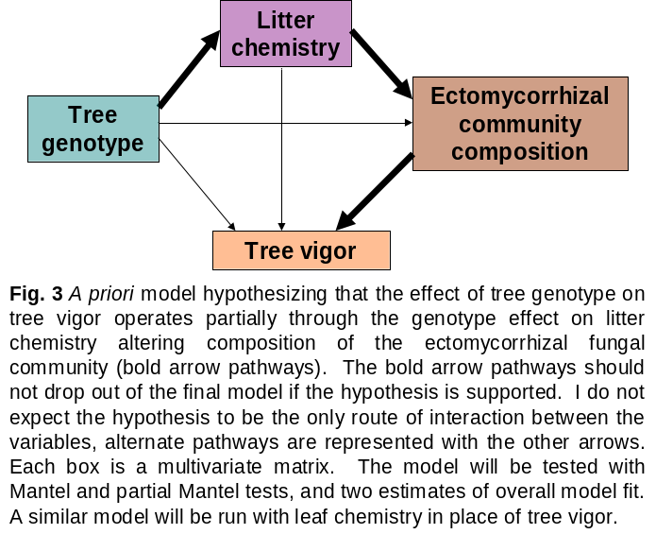
Statistical analysis: Testing the four hypotheses will require several levels of statistical analysis. First, I will establish whether components of fungal community structure vary among tree genotypes (Hypothesis 1). Variables of interest include overall colonization of root tips, total species richness, colonization by different individual fungal species and community composition. Differences among tree genotypes in univariate fungal measures will be tested with one-way analysis of variance, followed by calculation of broad-sense heritability (Conner and Hartl 2004). Ectomycorrhizal fungal species composition will be visually examined using nonmetric multidimensional scaling (NMDS), and differences among genotypes will be tested with a multivariate-response permutation procedure (MRPP) followed by estimates of broad-sense community heritability (McCune and Grace 2002, Shuster et al. 2006). The relationships between litter chemistry and ectomycorrhizal fungal communities (Hypothesis 2), as well as ectomycorrhizal community patterns with green leaf foliar chemistry and tree vigor (Hypothesis 3), will be analyzed using Pearson’s correlations, Mantel matrix correlations and joint-biplot vector analyses where appropriate (McCune and Grace 2002).
Finally, I plan to use a path model approach based on Mantel and partial Mantel tests (Leduc et al. 1992) to link tree genotype to its litter phytochemistry, litter phytochemistry to the ectomycorrhizal fungal community, and the ectomycorrhizal fungal community to tree vigor and defensive chemistry (Hypothesis 4; See Fig. 3 for the a priori model). The overall fit of this hypothesized model will be tested using randomization based procedures designed for structural equation modeling (SEM) with small sample sizes (Shipley 2000, Grace 2006), which will give an indication of whether or not the empirical data fit the hypothesized causal model structure. I recognize the circular nature of this analysis and hypothesis, because some green leaf chemicals enter soil through litter fall and affect ectomycorrhizal fungi. However, I believe that this loop begins with litter accumulation as a tree ages, therefore the initial start of this cycle is litter fall.

Chapter 2: Untangling relationships among tree genotype, ectomycorrhizal fungi and twig endophytes.

Introduction: This chapter focuses on experimentally examining relationships among ectomycorrhizal fungi, twig endophytes and P. angustifolia genotypes. Ectomycorrhizal and endophytic fungi can have important effects on host plant physiology, growth, and defense (Pinto et al. 2000, Arnold et al. 2003, Arnold and Engelbrecht 2007, Herre et al. 2007, Quoreshi and Khasa 2008). Ectomycorrhizal fungi and endophytes are also affected directly and indirectly by properties of the host plant. For example, phytochemical differences among plant species influence the endophyte communities that colonize their leaves (Arnold et al. 2003), and genetic influences on susceptibility to herbivores may feed back to alter ectomycorrhizal fungal communities (Gehring et al. 1997). Finally, through their effects on host plants, ectomycorrhizal and endophytic fungi may indirectly influence each other, as has been shown for AM fungi and systemic grass endophytes (Table 1). Understanding these interactions will help elucidate the mechanisms creating ecological patterns in fungal communities, as well as plant performance, chemistry and functional traits. Some of these traits, such as phytochemistry, can have extended affects on other associated organisms and ecosystem processes, including herbivores and nutrient cycling, respectively (Schweitzer et al. 2005, Wimp et al. 2008), making this topic broadly important. Below I outline my hypotheses and methods for a greenhouse inoculation experiment aimed at untangling some of the causal relationships that may occur. It is important to note that I am focusing on twig endophytes because culturable leaf endophytes in P. angustifolia seem to be too rare to work with (Wilson 1995b, Bailey et al. 2005, Lamit et al. unpublished).

Hypotheses:

1.) Twig endophytes, ectomycorrhizal fungi and tree genotype will individually and interactively affect tree performance, functional traits and chemistry.

2.) The presence of ectomycorrhizal fungi will shift the abundance of established endophytic fungi, and affect the ability of inoculated endophytes to colonize new shoot growth.

Design and methods: This greenhouse experiment will be in the form of a three-way full factorial design, with + or – ectomycorrhizal fungi, + or – inoculated endophytic fungi and eight genotypes as the three factors (I would consider downsizing to five genotypes for logistical reasons). Each unique factor level combination will contain 12 replicates, for a total of 384 trees. To accomplish this, I would prefer entirely fungus free cottonwood plants. I have already propagated cuttings in sterile soil, which should be free of mycorrhizal fungal propagules, and am watering from the bottom-up to avoid wetting aboveground tissue and facilitating new endophyte colonization. However, because cuttings from adult trees already contain endophytic fungi, these plants are not entirely endophyte free. I propose to inoculate cuttings with agar plugs containing ectomycorrhizal fungal cultures, following the methods of Ekblad et al. (1995). Inoculated plants will be allowed to grow for approximately two months. Then, new shoot growth will be inoculated with endophytic fungi following similar methods to Arnold et al. (2003). Plants will be watered with a drip system to avoid colonization from other endophytes. After three additional months of growth I will take final measurements of the plants and harvest them.
There will be several types of measurements taken for this experiment. First, because I am using cuttings that show some variability in size, at the start of the experiment all trees will be measured for total height, root collar diameter, number of leaves, and shoot length of the current year’s growth. In addition, at least five extra trees from each genotype, spanning the range of sizes for trees within each genotype, will be destructively harvested and have their roots, leaves and stems weighed wet and dry to provide an estimate for the average starting biomass for each genotype. Shortly before harvesting, height, leaf number, current year’s shoot length, root collar diameter and SPAD (a measure of chlorophyll content based on leaf greenness) will be measured. Several mature leaves per plant will then be collected, weighed wet, and have their area scanned. These will be flash frozen on dry ice and later freeze-dried and weighed before analysis of nitrogen, carbon, phosphorus, condensed tannins and phenolic glycosides. Plants will then be harvested and a subsection of standardized length of new shoot growth and the original cutting will be weighed wet and cut into pieces approximately 1cm long. These will be surface sterilized and plated on agar for endophyte quantification following the protocol in Bailey et al. (2005). I will estimate the dry weight of these sections using a wet to dry weight conversion I will create with extra cuttings. A subsection of roots will be frozen to later score colonization of ectomycorrhizal fungi. These roots will be dried and weighed after they are scored. The rest of each plant will be divided into leaves, shoots and roots and oven dried before taking biomass measurements. The different components of biomass for each plant will be added together to examine root, shoot, leaf, root:aboveground, and total plant biomass, after subtracting the average genotype biomass at the beginning of the experiment.
I propose to use single species for inoculations of both ectomycorrhizal fungi and endophytic fungi. Although trees in the real world contain communities of both groups, I feel that single species inoculations will be easier to carry out. If this study works, I am open to future studies with communities of each group of fungi. The ectomycorrhizal fungus Hebeloma crustuliniforme will be used for ectomycorrhizal fungal inoculations. This species is chosen because I have live cultures of it from the cottonwood common in Ogden and it is known to positively affect Populus spp. (Marmeisse et al. 1999). For endophyte inoculations I will use an unidentified species of Cytospora. I have live cultures of this species from cottonwoods growing at the Ogden common garden where it is a common community member, and its isolation frequency differs among P. angustifolia genotypes (Lamit et al. unpublished).

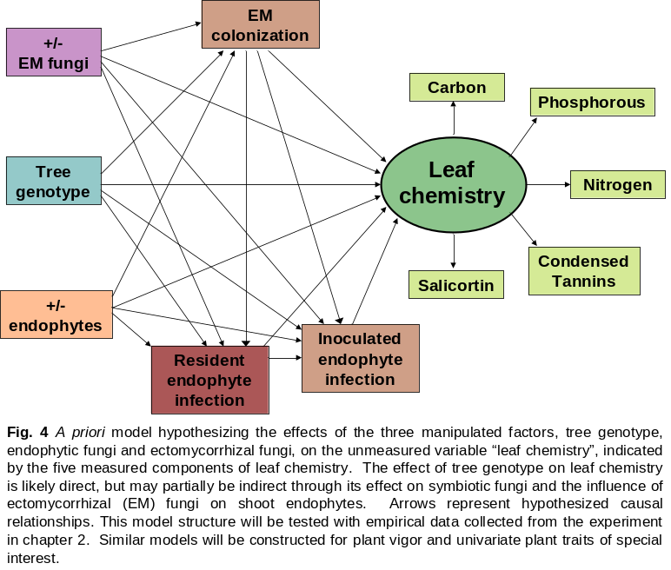
Statistical analyses: Data will be analyzed in two frameworks to address both hypothesis one and two. First, all response variables will be analyzed in a three factor multivariate analysis of variance (MANOVA), too ensure that there is an overall response to the factors. This will be followed by three-way ANOVA on each response variable, and broad-sense heritability estimates for each response variable. The bivariate relationships between resident endophyte infection, inoculated endophyte infection and ectomycorrhizal colonization will be analyzed with Pearson’s correlations. This will indicate potential interactions between the fungal groups. Second, I will use SEM, which is an integration of path analysis and factor analysis, to understand the structure of the overall system and causal pathways operating within it (Shipley 2000, Grace 2006). A priori models will focus on two main phenomena; the first is foliar chemistry, which will be represented by the components of foliar chemistry which I measure (Fig. 4); the second is plant vigor, which will be represented by the indicators of plant vigor I will measure. In addition, models focusing on specific plant traits of interest, for example specific leaf area, may also be tested. In each model, the strength of individual paths will be examined, as well as several measures of overall model fit (Grace 2006).

Chapter 3: Fungal communities and tree traits along an elevation gradient: covariances and environmental controls.

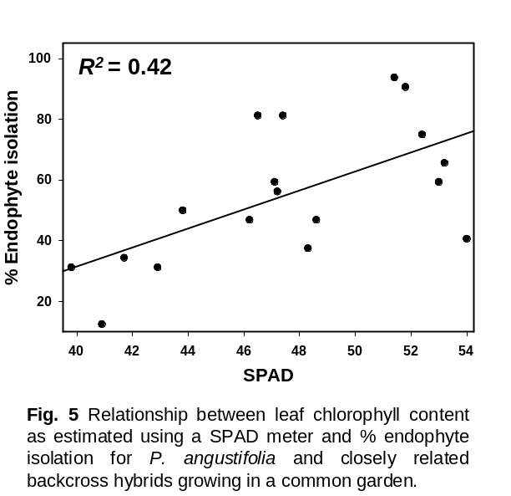
Introduction: This chapter focuses on P. angustifolia ectomycorrhizal and endophytic fungal community patterns along an elevation gradient. Natural gradients, such as elevation and latitude, which can share many similar characteristics, are commonly used to examine the influence of environmental factors on ecological and evolutionary phenomena (Reich et al. 1996, Gornall and Guy 2007, Körner 2007). Abiotic variables such as precipitation, nutrient availability, soil moisture and temperature, biotic variables including vegetation associations and genetic differences within plant species, and ecosystem processes such as decomposition and productivity often shift along gradients of elevation and latitude (Haselwandter and Read 1980, Reich et al. 1996, Martin et al. 2006, Gornall and Guy 2007, Körner 2007, Lojewski 2007). Plant associated fungi are sensitive to these variables (Gehring et al. 1998, Elamo et al. 1999, Avis et al. 2003, Gehring et al. 2006, Kranabetter et al. 2009), and therefore community level shifts likely occur across elevation and latitude gradients in response to changes in multiple abiotic and biotic factors. Some studies have demonstrated changes in components of fungal communities, including abundance, richness, species composition and phylogenetic composition, along elevation or latitude gradients (Haselwandter and Read 1980, Elamo et al. 1999, Gehring et al. 2006, Arnold and Lutzoni 2007, Lugo et al. 2008), however patterns and mechanisms are still little understood. The first goal of this chapter is to document and compare shifts in communities of ectomycorrhizal and endophytic fungi as abiotic and host genetic variables change with elevation. Patterns between the fungal groups may be correlated due to shared responses to similar environmental variables along an elevation gradient, or shifts in the strength or nature of their interactions.
The second component of this chapter will focus on identifying tree traits predictive of fungal community patterns. Identifying predictive relationships is a major goal in ecology (Bangert et al. 2006, Shipley et al. 2007), however it seems that fungal community ecology trails in this venture. Plant functional traits can be surprisingly predictable across abiotic gradients associated with elevation and latitude (Reich et al. 2003, Wright et al. 2004, Gornall and Guy 2007, Martin et al. 2007). These patterns are likely caused by selective pressures for plant species and genotypes capable of functioning efficiently and maximizing fitness in particular environmental contexts (Reich et al. 2003). Plant associated fungal communities, which are sensitive to some of these traits and affect others, may exhibit correlative patterns with them. For example, in a pilot study, I found that leaf SPAD measurements are both genetically linked and correlate with shoot endophyte isolation frequency (Fig. 5). If these plant and fungal variables shift due to elevation and tree genetic gradients associated with elevation, they may be expected to covary strongly over small and large spatial scales. In addition to documenting shifts in fungal communities with elevation, I would like to identify easily measurable genetically based tree traits that show consistent relationships with aspects of fungal community structure.

Hypotheses:

1.) Communities of ectomycorrhizal fungi and twig endophytes will shift with elevation due to changes in the abiotic environment and genetics of P. angustifolia.

2.) Components of fungal community structure, such as abundance, richness and composition, will covary between ectomycorrhizal and endophytic fungal communities along an elevation gradient.

3.) Plant traits will vary along an elevation gradient due to changes in the abiotic environment and genetics of P. angustifolia.

4.) Some plant traits will be correlated with fungal community patterns, making them candidates as general useful predictors of aspects of fungal community structure.

Design and Methods: This chapter requires trees to be sampled along an elevation gradient, which will likely be the one associated with the Weber River and its tributaries near my common garden sites in northern Utah. The first task will be to choose a set of trees. I prefer the sample trees to cover the elevation range of P. angustifolia, with their elevations, local precipitation levels and spatial locations not strongly autocorrelated. Due to the topography of the area, I believe that I can partially meet these requirements by sampling single trees (as opposed to multiple trees at any one site) spread through the Weber River and its tributaries, including the adjacent Ogden River. Ideally I would like at least sixty trees.
Sampling would entail characterization of fungal communities, tree traits and environmental variables. In all cases, samples will be collected from the north and south side of each tree and pooled per tree. Roots for ectomycorrhiza sampling will be collected with a hand trowel and processed with the same methods used in chapter one, with the addition of having their large ribosomal subunit (LSU) region sequenced. Endophytes will be isolated from 45 young twig segments (15 each from one, two and three year-old growth) following the protocol of Bailey et al. (2005), although I am open to switching from potato dextrose agar to malt extract agar. Twig segments will be watched for up to several months, after which fungal colonies will be morphotyped, and representatives of each morphotype will have their ITS and LSU regions sequenced. Another set of twig segments from each tree will be frozen and a subset may be analyzed with direct environmental PCR methods following Arnold et al. (2007). Environmental data include variables obtainable from databases such as mean annual temperature and precipitation, and soil parameters such as texture, moisture and nutrients that will need to be measured. The suite of tree traits measured will be partially dictated by those which are found to be linked to fungal variables in my previous chapters, and by their relative ease of measurement (remember, I am trying to identify general easy to measure predictive traits). Some of the possibilities include indicators of tree vigor such as height, diameter at breast height and shoot growth, phenological traits including leaf bud break, catkin bud break and timing of fall leaf drop, leaf chemical measurements like nitrogen, phosphorus and condensed tannin concentrations (although these may not be included because they are not very easy to measure), and other potentially important variables such as specific leaf area and SPAD.
Patterns that may emerge from this study could be due to both tree genetic and environmental factors, and the interplay of the two. To solidify the genetic basis, I am open to two options. One would be to collect genetic data from each tree and incorporate it into my analysis. Along this same line, I could possibly use trees that have already been genotyped, however it will be difficult to find trees that fit my sampling criterion that are all genotyped. The other option is to also sample trees in the common garden in Ogden, which contains about 40 P. angustifolia genotypes from the same elevation gradient planted in a common environment. There are pros and cons of either option.

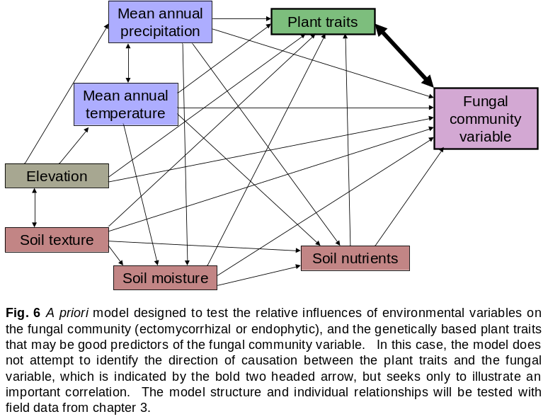
Statistical analyses: There will be multiple ways to look at this dataset, and here I outline a few that I believe are most important to testing my hypotheses. To address hypothesis one, univariate fungal community variables, including abundance and richness will be subjected to pairwise Pearson’s correlations with elevation. Species composition and phylogenetic composition (i.e., community composition that incorporates phylogenetic relationships based on the UniFrac method of Lozupone and Knight 2005) will be ordinated with NMDS and elevation will be correlated in ordination space with a joint-biplot analysis. Ectomycorrhizal and endophytic fungal community measures, in conjunction with elevation, will be correlated using pairwise Pearson’s correlations and Mantel correlations in a path analysis framework to examine whether or not the correlations are due to elevation (Hypothesis two). Hypothesis three will be tested with Pearson’s correlations between plant traits and elevation. To address hypothesis four, I will conduct a multiple regression analysis between tree traits and univariate fungal parameters, and a partial Mantel analysis between vectors of univariate tree traits and the multivariate components of fungal community structure. This will help identify tree traits that may be important predictive indicators of fungal community structure. To synthesize the findings from this study into a holistic picture in order to understand how elevation and the environmental variables interrelate to affect the fungal communities and correlated tree traits, I will use an SEM approach (Fig. 6). This will allow me to examine the relative strengths of each variable, and identify the factors that may be causing the covariance between the tree traits and fungal community.

References

Arnold, A. E., Mejía, L. C., Kyllo, D., Rojas, E. I., Maynard, Z., Robbins, N. and Herre, E. A. 2003. Fungal endophytes limit pathogen damage in a tropical tree. - Proceedings of the National Academy of Sciences 100: 15649-15654.
Arnold, A. E. 2007. Understanding the diversity of foliar endophytic fungi: progress, challenges, and frontiers. - Fungal Biology Reviews 21: 51-66.
Arnold, A. E. and Engelbrecht, B. M. J. 2007. Fungal endophytes nearly double minimum leaf conductance in seedlings of a neotropical tree species. - Journal of Tropical Ecology 23: 1-4.
Arnold, E., Henk, D. A., Eells, R. L. Lutzoni, F. and Vilgalys, R. 2007. Diversity and phylogenetic affinities of foliar fungal endophytes in loblolly pine inferred by culturing and environmental PCR Mycologia 99: 185- 206.
Arnold, A. E. and Lutzoni, F. 2007. Diversity and host range of foliar fungal endophytes: Are tropical leaves biodiversity hotspots? -Ecology 88: 541-549.
Avis, P. G., McLaughlin, D. J., Dentinger, B. C. and Reich, P. B. 2003. Long-term increase in nitrogen supply alters above- and below-ground ectomycorrhizal communities and increases the dominance of Russula spp. in a temperate oak savana. - New Phytologist: 239-253.
Bailey, J. K., Deckert, R., Schweitzer, J. A., Rehill, B. J., Lindroth, R. L., Gehring, C. A. and Whitham, T. 2005. Host plant genetics affect hidden ecological players: links among Populus, condensed tannins, and fungal endophyte infection. - Canadian Journal of Botany 83: 356-361.
Bailey, J. K., Wooley, S. C., Lindroth, R. L. and Whitham, T. G. 2006. Importance of species interactions to community heritability: a genetic basis to trophic-level interactions. - Ecology Letters 9: 78-85.
Bangert, R. K., Turek, R. J., Rehill, B., Wimp, G. M., Schweitzer, J. A., Allan, G. J., Bailey, J. K., Martinsen, G. D., Keim, P., Lindroth, R. L. and Whitham, T. G. 2006. A genetic similarity rule determines arthropod community structure. - Molecular Ecology 15: 1379-1391.
Barker, G. M. 1987. Mycorrhizal infection influences Acremonium induced restistance to argentine stem weevil in
ryegrass. Proceedings of the 40th New Zealand Weed and Pest Control Conference.
Barker, S. J. and Tagu, D. 2000. The roles of auxins and cytokinins in mycorrhizal symbioses. - Journal of Plant Growth Regulation 144: 144-154.
Baxter, J. W. and Dighton, J. 2001. Ectomycorrhizal diversity alters growth and nutrient acquisition of grey birch (Betula populifolia) seedlings in host-symbiont culture conditions. - New Phytologist 152: 139-149.
Binkley, D. and Giardina, C. 1998. Why do tree species affect soils? The warp and woof of tree-soil interactions. - Biogeochemistry 42: 89-106.
Boecklen, W. J. and Spellenberg, R. 1990. Structure of herbivore communities in two oak (Quercus spp.) hybrid zones. - Oecologia 85: 92-100.
Brundrett, M. C. 2002. Coevolution of roots and mycorrhizas of land plants. - New Pytologist 154: 275-304.
Conner, J. K. and Hartl, D. L. 2004. A Primer of Ecological Genetics. - Sinauer Associates. Sunderland, Massachusetts.
Crutsinger, G. M., Souza, L. and Sanders, N. J. 2008. Intraspecific diversity and dominant genotypes resist plant invasion. - Ecology Letters 11: 16-23
Dayton, P. K. 1972. Toward an understanding of community resilience and the potential effects of enrichments to the benthos at McMurdo Sound, Antarctica. - In: Parker, B. C. (ed.) Proceedings of the Colloquium on Conservation Problems. - Allen Press, Lawrence, Kansas, pp. 81-96.
Ekblad, A., Wallander, H., Carlsson, R. and Huss-Danell, K. 1995. Fungal biomass in roots and extramatrical mycelium in relation to macronutrients and plant biomass of ectomycorrhizal Pinus sylvestris and Alnus incana. - New Phytologist 131: 443-451.
Elamo, P., Helander, M. L., Saloniemi, I. and Neuvonen, S. 1999. Birch family and environmental conditions affect endophytic fungi in leaves. - Oecologia 118: 151-156.
Ellison, A. M., Bank, M. S., Clinton, B. D. and bob, T. 2005. Loss of a foundation species: consequences for the structure and dynamics of forested ecosystems. - Frontiers in Ecology and the Environmet 3: 479-486.
Floate, K. D., Kearsley, M. J. C. and Whitham, T. G. 1993. Elevated herbivory in plant hybrid zones: Chrysomela confluens, Populus and phenological sinks. - Ecology 74: 2056-2065.
Gehring, C. A., Cobb, N. S. and Whitham, T. G. 1997. Three-way interactions among ectomycorrhizal mutualists, scale insects and resistant and susceptible pinyon pines. - American Naturalist 149: 824-841.
Gehring, C. A., Theimer, T. C., G., W. T. and Keim, P. 1998. Ectomycorrhizal fungal community structure of pinyon pines growing in two environmental extremes. - Ecology 79: 1562-1572.
Gehring, C. A., Mueller, R. C. and Whitham, T. G. 2006. Environmental and genetic effect on the formation of ectomycorrhizal and arbuscular mycorrhizal associations in cottonwoods. - Oecologia 149: 158-164.
Gornall, J. L. and Guy, R. D. 2007. Geographic variation in ecophysiological traits of black cottonwood (Populus trichocarpa). - Canadian Journal of Botany 85: 1202-1213.
Grace, J.B. (2006) Structural Equation Modeling in Natural Systems. Cambridge University Press, Cambridge, UK.
Grime, J. P., Thompson, K., R. Hunt, Hodgson, J. G., Cornelissen, J. H. C., Rorison, I. H., Hendry, G. A. F., Ashenden, T. W., Askew, A. P., Band, S. R., Booth, R. E., Bossard, C. C., Campbell, B. D., Cooper, J. E. L., Davison, A. W., Gupta, P. L., Hall, W., Hand, D. W., Hannah, M. A., Hillier, S. H., Hodkinson, D. J., Jalili, A., Liu, Z., Mackey, J. M. L., Matthews, N., Mowforth, M. A., Neal, A. M., Reader, R. J., Reiling, K., Ross-Fraser, W., Spencer, R. E., Sutton, F., Tasker, D. E., Thorpe, P. C. and Whitehouse, J. 1997. Integrated Screening Validates Primary Axes of Specialisation in Plants Integrated Screening Validates Primary Axes of Specialisation in Plants. - Oikos 79: 259-281.
Guo, B. Z., Hendrix, J. W., An, Z.-Q. and Ferriss, R. S. 1992. Role of Acromonium endophyte of fescue on inhibition of colonization and reproduciton of mycorrhizal fungi. - Mycologia 84: 882-885.
Harrington, T. J. and Mitchell, D. T. 2005. Ectomycorrhizas associated with a relict population of Dryas octopetala In the Burren, western Ireland. I. Distribution of ectomycorhizas in relation to vegetation and soil characteristics. - Mycorrhiza 15: 425-433.
Haselwandter, K. and Read, D. J. 1980. Fungal associations of roots of dominant and sub-dominant plants in high- alpine vegetation systems with special reference to mycorrhiza. - Oecologia 45: 57-62.
Hättenschwiler, S. and Vitousek, P. M. T. 2000. The role of polyphenols in terrestrial ecosystem nutrient cycling. - Trends in Ecology and Evolution 15: 238-243.
Hawksworth, D. L. 2001. The magnitude of fungal diversity: the 1.5 million species estimate revisited. - Mycological Research 105: 1422-1432.
Herre, E. A., Mejía, L. C., Kyllo, D. A., Rohas, E., Maynard, Z., Butler, A. and Van Bael, S. A. 2007. Ecological implications of anti-pathogen effects of tropical fungal endophytes and mycorrhizae. - Ecology 88: 550- 558.
Higgins, K. L., Arnold, A. E., Miadlikowska, J., Sarvate, S. D. and Lutzoni, F. 2007. Phylogenetic relationships, host affinity, and geographic structure of boreal and arctic endophytes from three major plant lineages. - Molecular Phylogenetics and Evolution 42: 543-555.
Horton, T. R. and Bruns, T. D. 2001. The molecular revolution in ectomycorrhizal ecology: peeking into the black- box. - Molecular Ecology 10: 1855-1871.
Ishida, T. A., Nara, K. and Hogetsu, T. 2007. Host effects on ectomycorrhizal fungal communities: insight from eight host species in mixed conifer-broadleaf forests. - New Phytologist 174: 430-440.
Johnson, M. T. J. and Agrawal, A. A. 2005. Plant genotype and the environment interact to shape a diverse arthropod community on evening primrose (Oenothera biennis). - Ecology 86: 874-885.
Johnson, M. T. J. and Stinchcombe, J. R. 2007. An emerging synthesis between community ecology and evolutionary biology. - Trends in Ecology and Evolution 22: 250-257.
Johnson, N. C., Graham, J. H. and Smith, F. A. 1997. Functioning of mycorrhizal associations along the mutualism-
parasitism continuum. - New Phytologist 135: 575-585.
Keith, A. R., Bailey, J. K. and Whitham, T. G. 2009. Community Heritability, Repeatability, and Stability of a Foundation Tree Species. - In review.
Körner, C. 2007. The use of 'altitude' in ecological research. - Trends in Ecology and Evolution 22: 569-574.
Kranabetter, J. M., Durall, D. M. and MacKenzie, W. H. 2009. Diversity and species distribution of ectomycorrhizal
fungi along productivity gradients of a southern boreal forest. - Mycorrhiza 19: 99-111.
Kraus, T. E. C., Dahlgren, R. A. and Zasoski, R. J. 2003. Tannins in nutrient dynamics of forest ecosystem- a review. - Plant and Soil 256: 41-66.
Leduc, A., Drapeau, P., Bergeron, Y. and Legendre, P. 1992. Study of spatial components of forest cover using partial Mantel tests and path analysis. - Journal of Vegetation Science 3: 69-78.
Lojewski, N. R. 2007. Tree genetics control belowground carbon allocation and whole-tree carbon partitioning in Populus. School of Forestry. - Northern Arizona University, master’s thesis.
Lozupone, C. and Knight, R. 2005. UniFrac: a new phylogenetic method for comparing microbial communities. – Applied and Environmental Microbiology 71: 8228-8235.
Lugo, M. A., Ferrero, M., Menoyo, E. and Estévez, M. C. 2008. Arbuscualr mycorrhizal fungi and rhizopheric bacteria diversity along an altitudinal gradient in South American puna grassland. - Microbial Ecology 55: 705-713.
Mack, K. M. L. and Rudgers, J. A. 2008. Balancing multiple mutualists: asymmetric interactions among plants, arbuscular mycorrhizal fungi, and fungal endophytes. - Oikos 117: 310-320.
Marmeisse, R., Gryta, H., Jargeat, P., Fraissinet-Tachet, L., Gay, G. and Debaud, J.-C. 1999. Hebeloma. - In: Cairney, J. W. G. and Chambers, S. M. (eds.), Ectomycorrhizal fungi: Key genera in profile. Springer. Heidelberg, Germany.
Martin, F., Duplessis, S., Ditengou, F., Lagrange, H., Voiblet, C. and Lapeyrie, F. 2001. Developmental cross talking in the ectomycorrhizal symbiosis: signals and communication genes. - New Phytologist: 145-154.
Martin, R. E., Asner, G. P. and Sack, L. 2007. Genetic variation in leaf pigment, optical and photosynthetic function among diverse phenotypes of Metrosideros polymorpha grown in a common garden. - Oecologia 151: 387- 400.
McCune, B. and Grace, J. B. 2002. Analysis of ecological communities. - MjM Software Design. Gleneden Beach, Oregon.
McGill, B. J., Enquist, B. J., Weiher, E. and Westoby, M. 2006. Rebuilding community ecology from functional traits. - Trends in Ecology and Evolution 21: 178-185.
Molina R, M. H., Trappe JM. In, ed. 1992. Specificity phenomena in mycorrhizal symbiosis: community ecological consequences and practical implications. - In: MF, A. (ed.) Mycorrhizal Functioning. Chapman and Hall, pp. 357-423.
Morris, H. M., Smith, M. E., Rizzo, D. M., Rejmánek, M. and Bledsoe, C., S. 2008. Contrasting ectomycorrhizal fungal communities on the roots of co-occuring oaks (Quercus spp.) in a California woodland. - New Phytologist 178: 167-176.
Müller, J. 2003. Artificial infection by endophytes affects growth and mycorrhizal colonisation of Lolium perenne. -
Functional Plant Biology 30: 419-424.
Neville, J., Tessier, J. L., Morrison, I., Scarratt, J., Canning, B. and Klironomos, J. N. 2002. Soil depth distribution of ecto- and arbuscular mycorrhizal fungi associated with Populus tremuloides within a 3-year-old boreal forest clear-cut. - Applied Soil Ecology 19: 209-216.
Northup, R. R., Dahlgren, R. A. and McColl, J. G. 1998. Polyphenols as regulators of plant-soil interactions in northern California's pygmy forest: A positive feedback? - Biogeochemistry 42: 189-220.
Novas, M. V., Cabral, D. and Godeas, A. M. 2005. Interaction between grass endophytes and mycorrhizas in Bromus setifolius from Patagonia, Argentina. - Symbiosis 40: 23-30.
Olsen, R. A., Odham, G., Lindeberg, G. and. 1971. Aromatic substances in leaves of Populus tremula as inhibitors of mycorrhizal fungi. - Physiology of Plants 25: 122-129.
Omacini, M., Eggers, T., Bonkowskis, M., Gange, A. C. and Jones, T. H. 2006. Leaf endophytes affect mycorrhizal status and growth of co-infected and neighbouring plants. - Functional Ecology 20: 226-232.
Pinto, L. S. R. C., Azevedo, J. L., Pereira, J. O., Vierira, M. L. C. and Labate, C. A. 2000. Symptomless infection of banana and maize by endophytic fungi impairs photosynthetic efficiency. - New Phytologist 147: 609- 615.
Quoreshi, A. M. and Khasa, D. P. 2008. Effectiveness of mycorrhizal inoculation in the nursery on root colonization, growth, and nutrient uptake of aspen and balsam poplar. - Biomass and Bioenergy 32: 381- 391.
Read, D. J. and Perez-Moreno, J. 2003. Mycorrhizas and nutrient cycling in ecosystems: a journey towards relevance? - New Phytologist 157: 475-492.
Redecker, D., Kodner, R. and Graham, L. E. 2000. Glomalean Fungi from the Ordovician. - 289: 1920 - 1921.
Reich, P. B., Oleksyn, J. and Tjoelker, M. G. 1996. Needle respiration and nitrogen concentration in Scots pine populations from a broad latitudinal range: a common garden test with field grown trees. - Functional Ecology 10: 768-776.
Reich, P. B., Wright, I. J., Cavender-Bares, J., Craine, J. M., Oleksyn, J., Westoby, M., Walters, M.B.. 2003. The evolution of plant functional variation: traits, spectra, and strategies. - International Journal of Plant Sciences 164: S143-S164.
Reusch, T. B. H., Ehlers, A., Hämmerli, A. and Worm, B. 2005. Ecosystem recovery after climatic extremes enhanced by genotypic diversity. - Proceedings of the National Academy of Sciences 102: 2826-2831.
Saikkonen, K., Faeth, S. H., Helander, M. and Sullivan, T. J. 1998. Fungal endophytes: a continuum of interactions with host plants. - Annual reviews of ecology and systematics.: 319-343.
Saikkonen, K., Helander, M. L. and Rousi, M. 2003. Endophytic foliar fungi in Betula spp. and their F1 hybrids. - Forest Pathology 33: 215-222.
Schweitzer, J. A., Bailey, J. K., Hart, S. C., Wimp, G. M., Chapman, S. K. and Whitham, T. G. 2005. The interaction of plant genotype and herbivory decelerate leaf litter decomposition and alter nutrient dynamics. - Oikos 110: 133-145.
Schweitzer, J. A., Bailey, J. K., Fischer, D. G., LeRoy, C. J., Lonsdorf, E. V., Whitham, T. G. and Hart, S. C. 2008. Soil microorganism-plant interactions: A heritable relationship between plant genotype and associated soil microorganisms. - Ecology 89: 773-781.
Schweitzer, J. A., Bailey, J. K., Fischer, D. G., LeRoy, C. J., Whitham, T. G. and Hart, S. C. 2009. Broad-sense heritability of soil processes: A genetic basis for ecosystem extended phenotypes? - Ecology: in revision.
Shipley, B. (2000) Cause and Correlation in Biology: A User’s Guide to Path Analysis, Structural Equations and Causal Inference. Cambridge University Press, Cambridge, UK.
Shipley, B., Lechowicz, M. J., Wright, I. and Reich, P. B. 2006. Fundamental trade-offs generating the worldwide leaf economics spectrum. - Ecology 87: 535-541.
Shipley, B., Vile, D. and Garnier, E. 2007. From plant traits to plant communities: a statistical mechanistic approach
to biodiversity. - Science 314: 812-814.
Shuster MS, L. E., Wimp GM, Bailey JK, Whitham TG. 2006. Community heritability measures the evolutionary consequences of indirect genetic effects on community structure. - Evolution 60: 991-1003.
Smith, S. E. and Read, D. J. 2008. Mycorrhizal Symbiosis. - Elsevier. Amsterdam.
Sthultz, C. M. 2008. Influence of genes, herbivores and drought on the mortality and ectomycorrhizal fungal community of a foundation tree. Department of biological sciences - Northern Arizona University. PhD dissertation.
Tagu, D., Lapeyrie, F. and Martin, F. 2002. The ectomycorrhizal symbiosis: genetics and development. - Plant and soil 244: 97-105.
Trappe, J. M. and Luoma, D. L. 1992. The ties that bind: fungi in ecosystems. - In: Carroll, G. C. and Wicklow, D. T. (eds.), The fungal community: its organization and role in the ecosystem. 2nd ed. Marcel Dekker, pp. 17- 27.
Van der Heijden, M. G. A., Klironomos, J. N., Ursic, M., Moutoglis, P., Streitwolf-Engel, R., Boller, T., Wiemken, A., Sanders, I. R. and. 1998. Mycorrhizal fungal diversity determines plant biodiversity, ecosystem variability and productivity. - Nature 396: 69-72.
Weiher, E., van der Werf, A., Thompson, K., Roderick, M., Garnier, E. and Eriksson, O. 1999. Challenging Theophrastus: A common core list of plant traits for functional ecology. - Journal of Vegetation Science 10: 609 - 620.
Westoby, M. and Wright, I. J. 2006. Land-plant ecology on the basis of functional traits. - Trends in Ecology and Evolution 21: 261-268.
Whitham, T. G., Young, W. P., Martinsen, G. D., Gehring, C. A., Schweitzer, J. A., Shuster, S. M., Wimp, G. M., Fischer, D. G., Bailey, J. K., Lindroth, R. L., Woolbright, S. A. and Kuske, C. R. 2003. Community and ecosystem genetics: A consequence of the extended phenotype. - Ecology 84: 559-573.
Whitham, T. G., Bailey, J. K., Schweitzer, J. A., Shuster, S. M., Bangert, R. K., LeRoy, C. J., Lonsdorf, E. V., Allan, G. J., DiFazio, S. P., Potts, B. M., Fischer, D. G., Gehring, C. A., Lindroth, R. L., Marks, J. C., Hart, S. C., Wimp, G. M. and Wooley, S. C. 2006. A framework for community and ecosystem genetics: from genes to ecosystems. - Nature Reviews Genetics 7: 510-523.
Whitham, T. G., DiFazio, S. P., Schweitzer, J. A., Shuster, S. M., Allan, G. J., Bailey, J. K. and Woolbright, S. A. 2008. Extending genomics to natural communities and ecosystems. - Science 320: 492-495.
Wilson, D. 1995a. Endophyte- the evolution of a term, and clarification of its use and definition. - Oikos 73: 274- 276.
Wilson, D. 1995b. Fungal endophytes which invade insect galls: insect pathogens, benign saprophytes, or fungal inquilines? - Oecologia 103: 255-260.
Wimp, G. M., Wooley, S., Bangert, R. K., Young, W. P., Martinsen, G. D., Keim, P., Rehill, B., Lindroth, R. L. and Whitham, T. G. 2008. Plant genetics predicts intra-annual variation in phytochemistry and arthropod community structure. - Molecular Ecology 16: 5057-5069.
Wright, I. J., Reich, P. B., Westoby, M., Ackerly, D., Baruch, Z., Cavender-Bares, J., Chapin, T., Cornelissen, H., Diemer, M., Garnier, E., Gulias, J., Hikosaka, K. and Lamont, B. 2004. The worldwide leaf economics
spectrum. - Nature 428: 821-827.

